**Proposal : 615929 (# Problem 1 : MainActivity)**

* Default Page

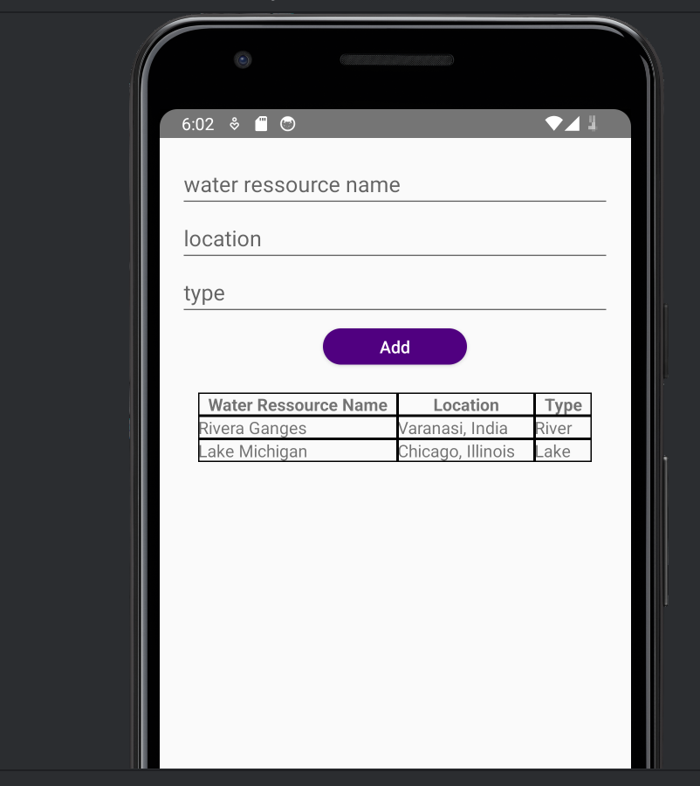

* Adding without all the fields

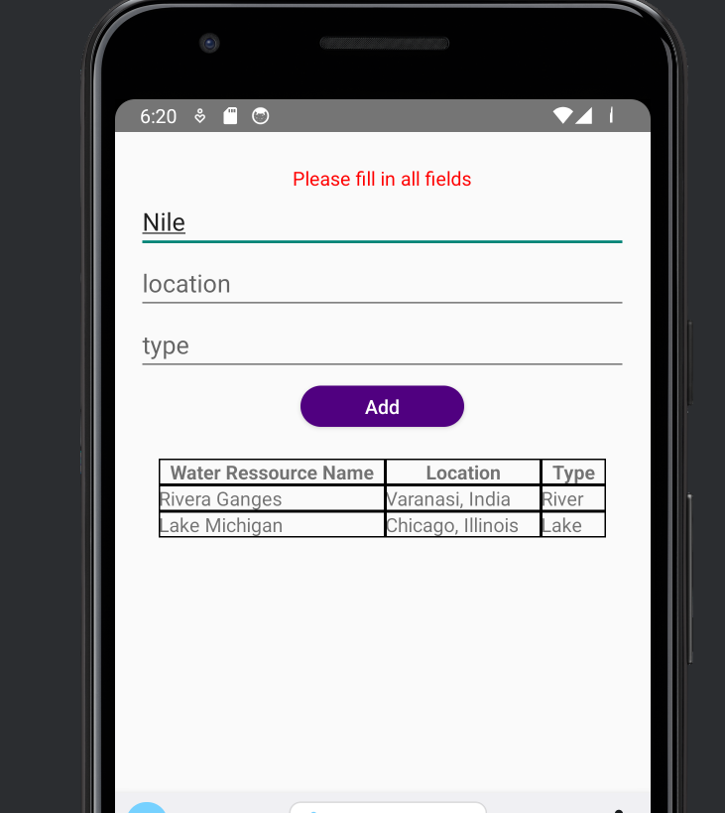

* Adding a new Water Ressource

Before After

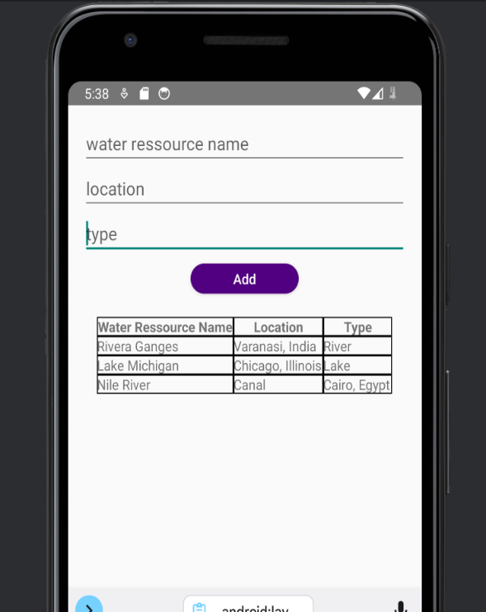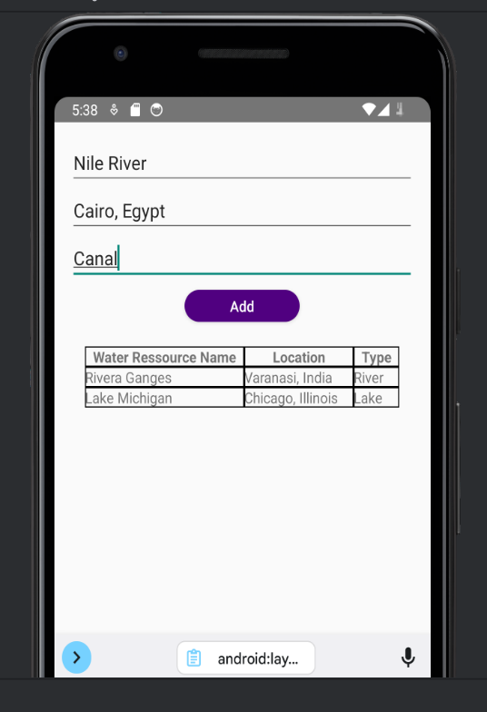

#Problem 2